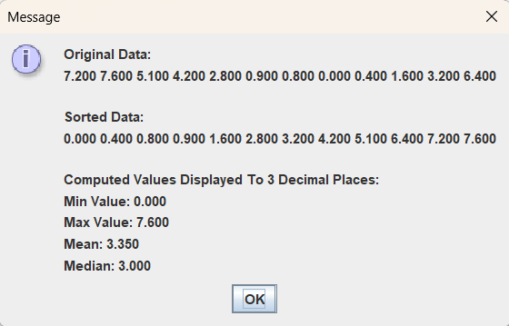

package as3;

import java.util.Arrays;

public class Statistics
{
// instance variables
private double[] data;
private double[] sdata;

// constructor Statistics
public Statistics(double[] d)
{
// clone returns a (shallow) copy of the array
data = d.clone();
sdata = d.clone();

// sort the array sdata
Arrays.sort(sdata);
}

// instance methods
public double findMin()
{
double min = sdata[0];
return min;
}

public double findMax()
{
double max = sdata[sdata.length - 1];
return max;
}

public double findMean()
{
double sum, mean;
sum = 0;
for (int i = 0; i < sdata.length; i++)
{
sum = sum + sdata[i];
}
mean = sum / sdata.length;
return mean;
}

public double findMedian()
{
double median = 0;
// Determine if the length is odd or even.
if ((sdata.length % 2) != 0)
{
int index = sdata.length / 2;
median = sdata[index];
} else
{
int indexHi = sdata.length / 2;
int indexLo = indexHi - 1;
median = (sdata[indexLo] + sdata[indexHi]) / 2;
}
return median;
}

// method returns a copy of the array data containing the original data.
public double[] getOrigData()
{
// create a new array d
double[] d = data.clone();
return d;
}

// method returns a copy of the instance variable array sdata containing the sorted data.
public double[] getSortedData()
{

double[] d = sdata.clone();
return d;
}
}

